**CMPE 207 : Network Programming and Applications**

**Homework 4: Memcached**

**Submitted by Team Network Ninjas (Shashank Bheemanapalli, Vidhatri Milind Joshi and Sahiti Shankar Varada)**

1. A php code is written and executed to show the performance boost while loading the web content using cache layer.

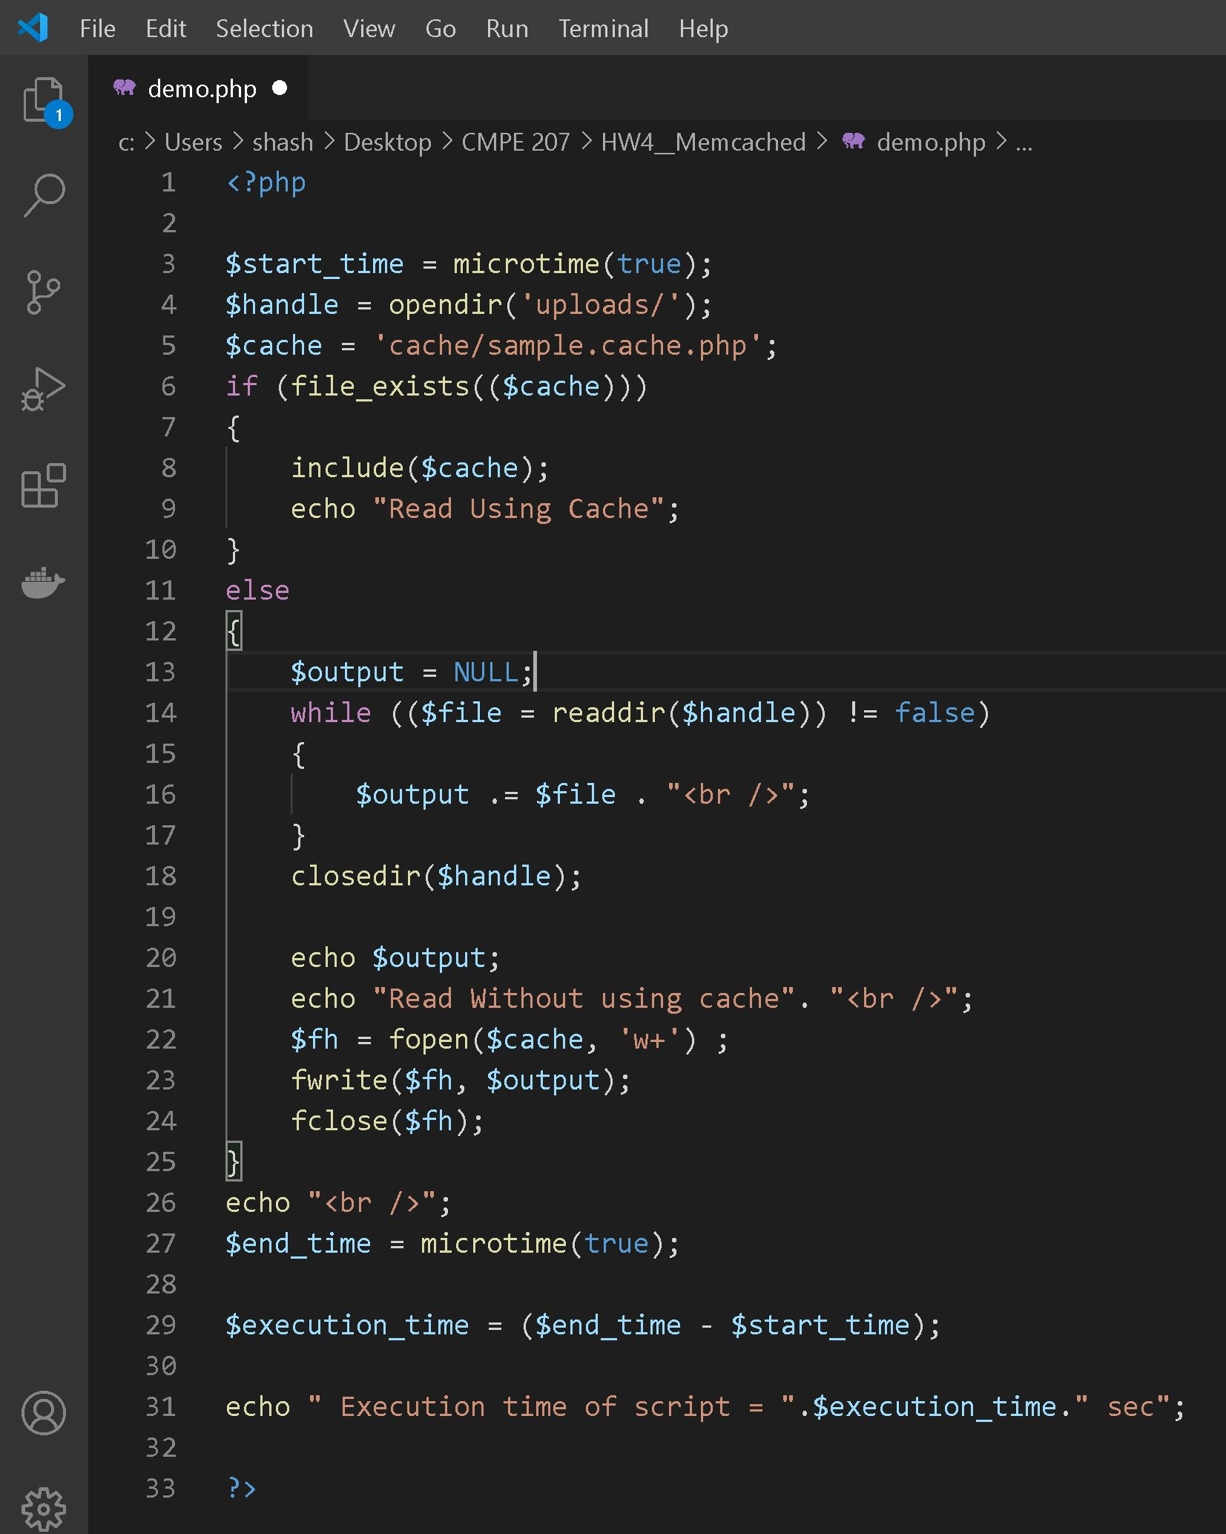

1. Here we can see the execution time when the web contents are accessed without caching.

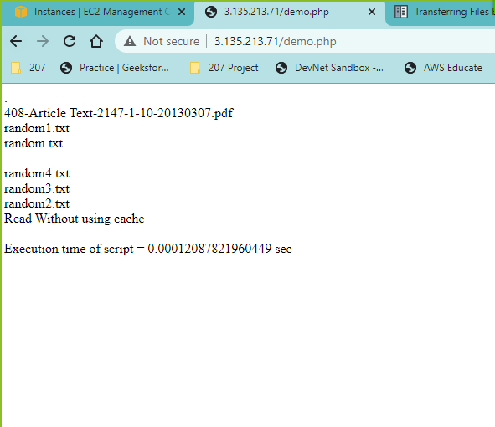

1. Here we can see the execution time when the web contents are accessed with caching.

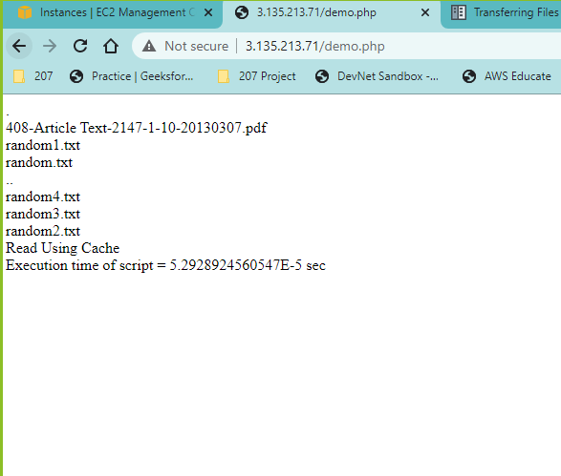

1. When the user tries to access the files for the first time, it will try to retrieve the contents from the Uploads folder instead of Cache folder, as the Cache Folder contents will be empty initially. The contents accessed are then copied to the Cache Folder.
2. When the user tries to access the files for the second time, it retrieves the contents from cache folder instead of uploads folder. Thus, the cache helps in accessing the files much faster. This is evident by comparing the execution time, without caching: 0.1208ms and with caching: 0.05292ms
3. The snapshot below shows the cached folder contents generated when the user accessed it for the first time.

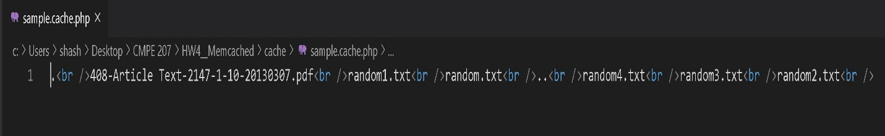

Source code: <https://github.com/Shashank-Bheemanapalli/Network-Programming-Projects.git>